How to Install Selenium on windows with the help of Maven.

Step 1:

Install Eclipse stable version (Oxygen) from internet.

Step 2:

Create a Workspace.

Step 3:

Go to File

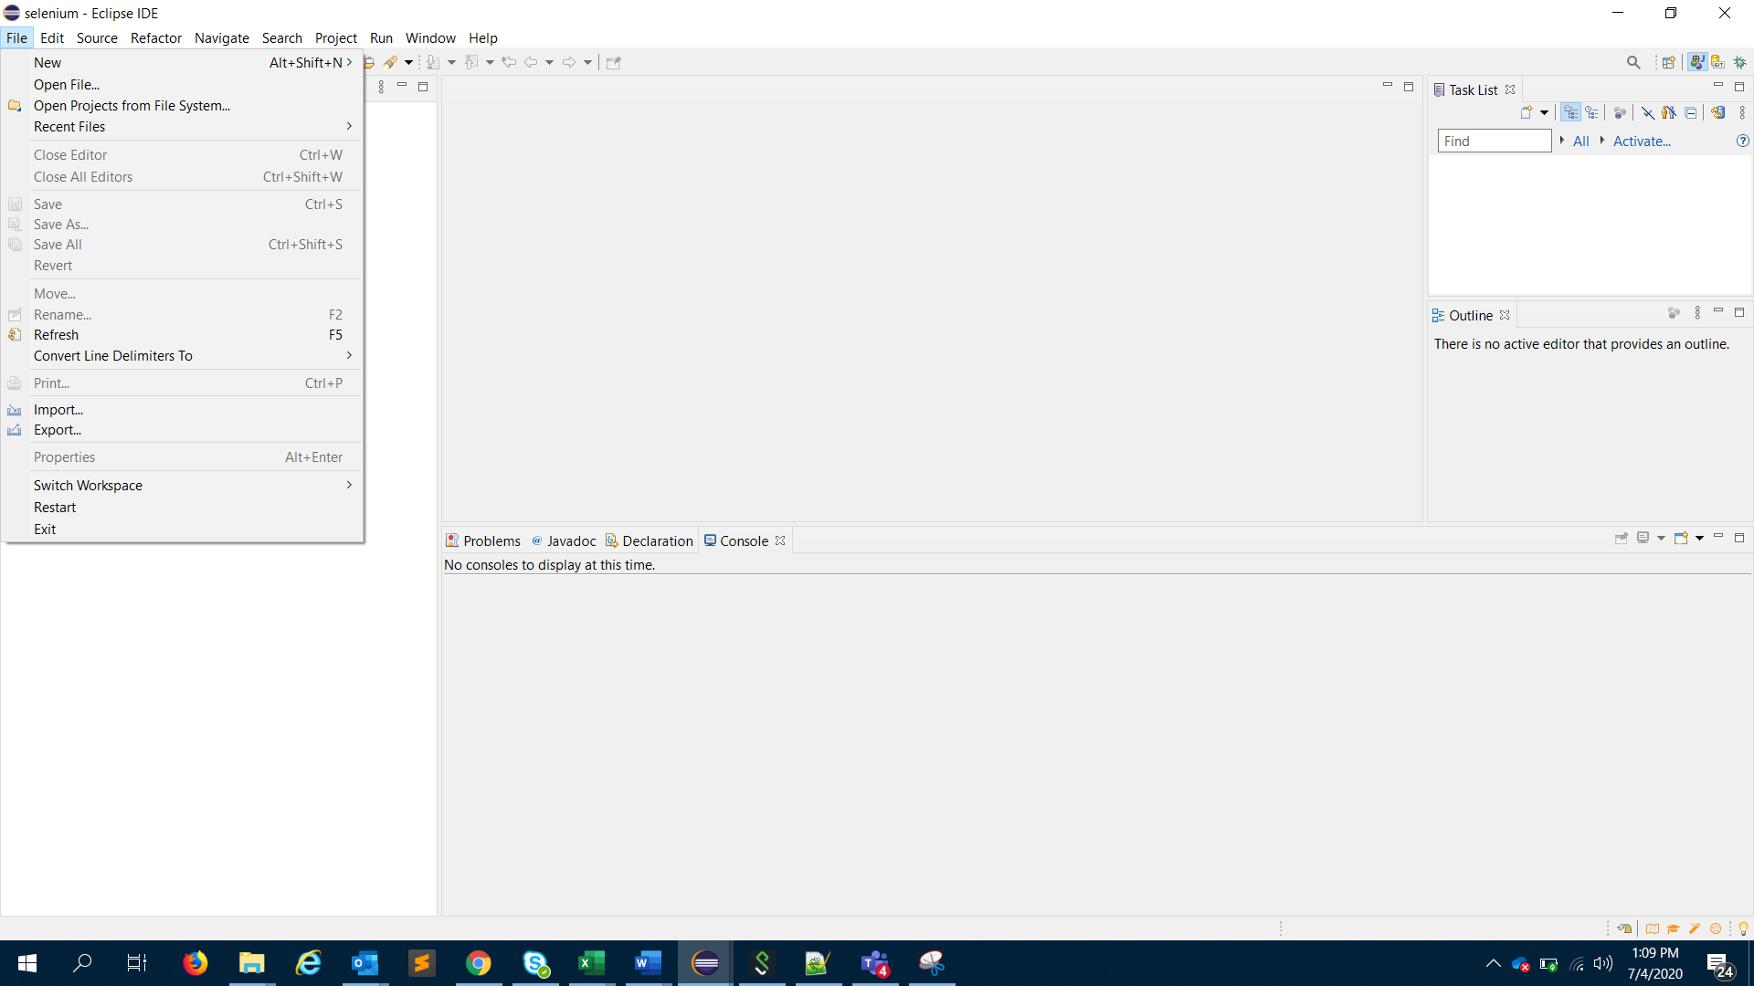

Step 4:

Navigate to New > Project

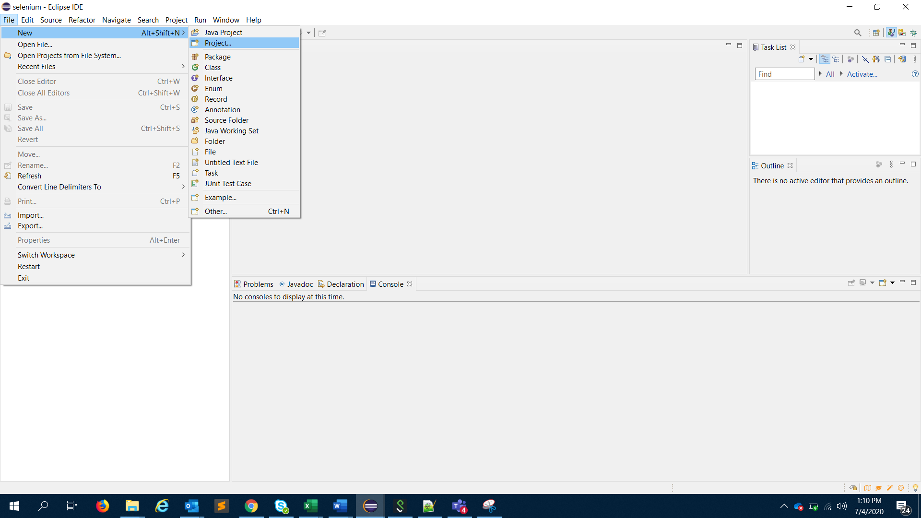

Step 5 :

Select Maven

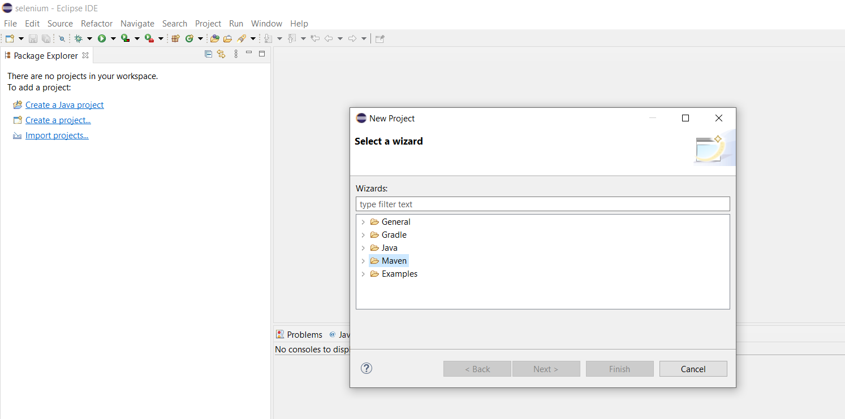

Step 6:

Go to Maven Project >Next

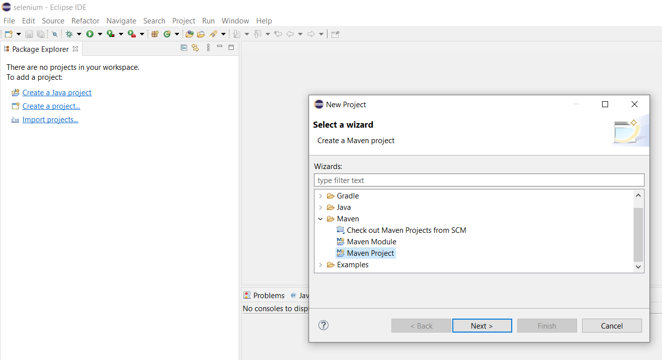

Step 7:

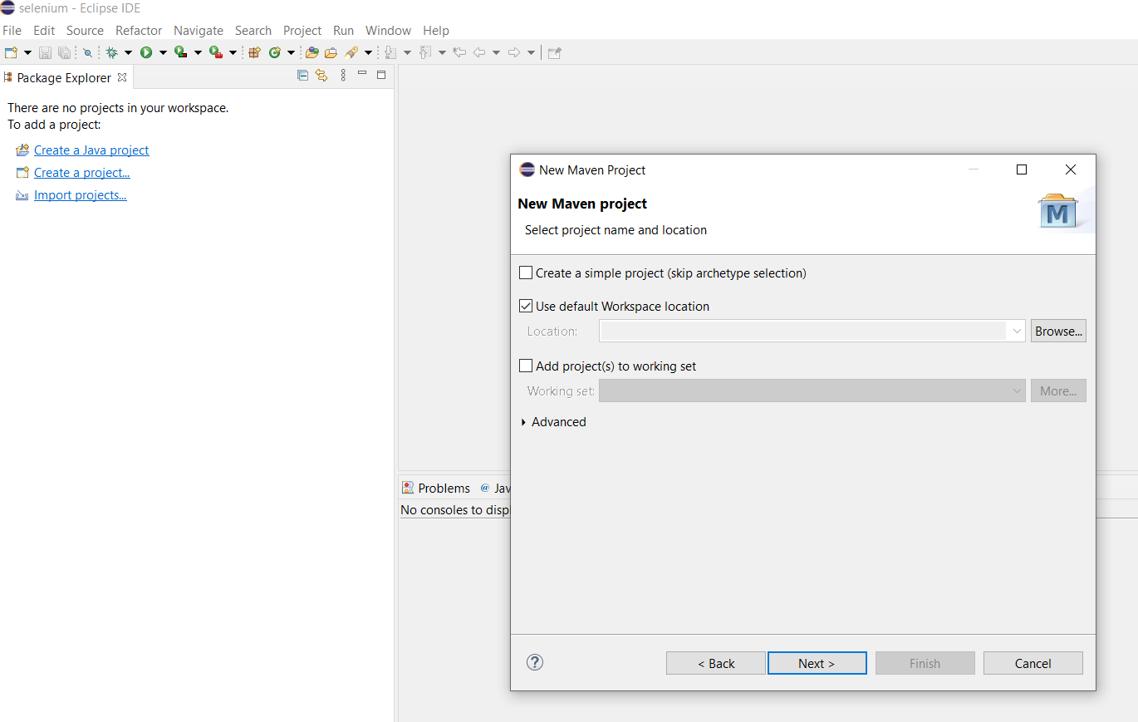

Step 8:

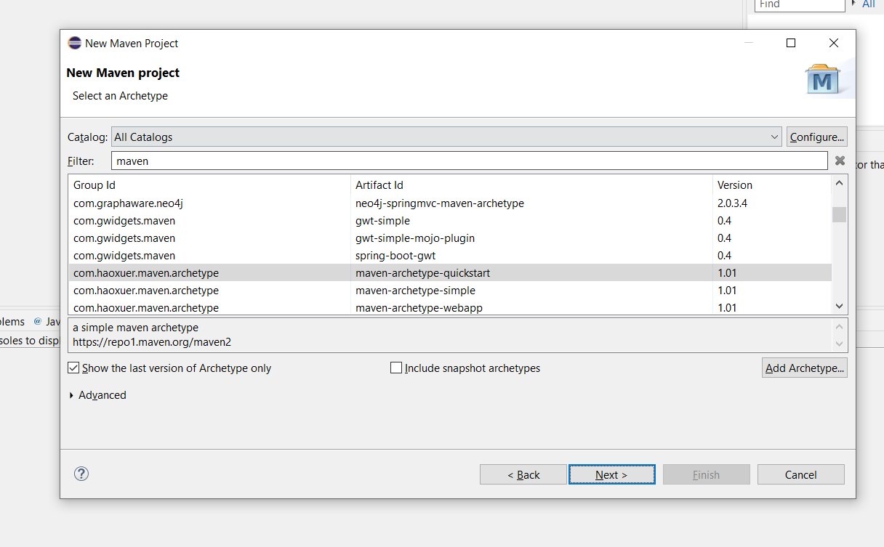

Step 9:

